Date: MAY 24 2021 File: C:\Karapetyan\18445 Резка заготовок\03_program\6\18445_6mm001.NST

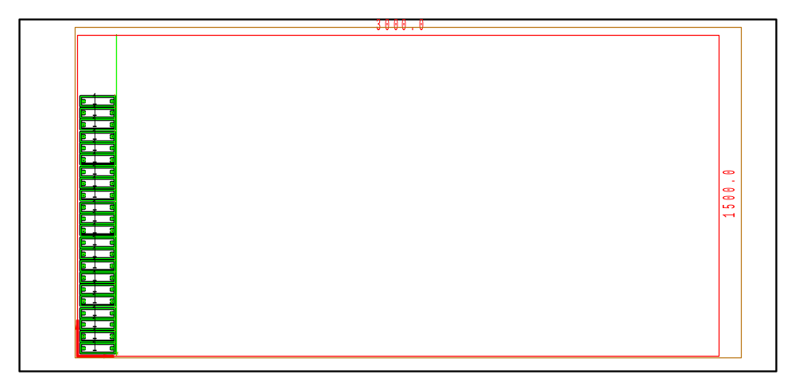

PART INFO
NC File Name: Ê!Å;Ä2LÅ5_6mm001ÅËÍ
Draft no.: | Version:
Order no.: | Description:
SHEET Number of sheets: 1
Material: Steel | Sheet size: 3000 X 1500 | T= 6.0
No. of parts: 22 | Part size:
Part weight: | Sheet weight: 210.60 kg
MACHINE:
MODEL: ML3015EX |  | Con. name: SS400 |  | Table name: ML45CF_R_EX
Gas: O2 | Lens: 7.5 Inches |  | Nozzle diameter: 1.2
Speed: 3200 |  | Used laser power: 4500 |  | Beam diameter (kerf): 0.52
PROGRAM
Number: 4156 | File size: 3179 | Programmer:
Notes:
JOB TIME (min:sec)
Travel: 00:23 | Cut: 04:12 | Pierce: 02:25
Travel way: 10485.4 mm | Cutting way: 0 mm | Pierce Qty.: 66
Total time: 07:00

 | Part name | DX | DY | QTY
1 | Ê#Å;Ä>UIÅ.004.04.01.002_$ËÍ | 160 | 45 | 22

